
STACK OVERFLOW BURGER
Every bite is full of fun, every burger is made with love! Crunchy, juicy, and packed with flavors, our burgers will make you come back for more.
FIREWALL WINGS

Spicy, crispy, and full of fire! One bite, and your taste buds will be on a flavor overload.”

ABOUT US!
Welcome to BYTE & BITE, where technology meets taste! At BYTE & BITE, we believe that every meal should be an experience. From sizzling burgers and crispy fries to delectable desserts and refreshing beverages, we craft each dish with passion and precision. Our modern, cozy atmosphere is perfect for friends, families, and food enthusiasts alike. Whether you’re here to enjoy a quick bite, celebrate a special moment, or explore our surprise deals, we promise a dining experience that’s both flavorful and memorable. Join us and take a delicious journey, byte by byte!
QUALITY YOU
CAN TASTE

BYTE & BITE
Where Taste Meets Technology

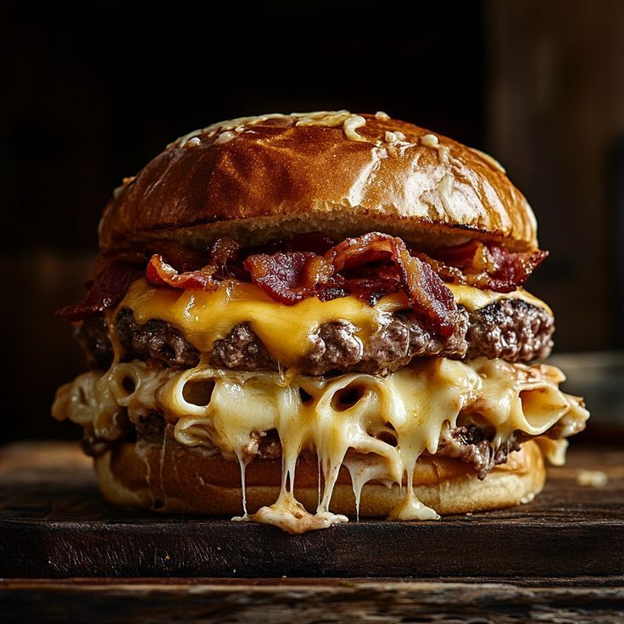

Delicious menu



MENU
POPULOR ITEMS
- Byte Fried Rice – Rs. 799
- Firewall Wings – Rs. 1199
- Code Fries – Rs. 799
- Stack Overflow Burger – Rs. 699
- Debugger Burger – Rs. 1299
Desserts:
- Byte Size Donuts – Rs. 599
- Cookie.exe – Rs. 399
Beverages:
- Java Shake – Rs. 499
- Binary Mint Majito – Rs. 599

Special Deals
Programmer Combo – Rs. 2499
“Perfect for coding sessions and hunger crashes! A complete meal with your favorite burgers, sides, and drinks.”
Student Combo – Rs. 1599
“Budget-friendly and tasty! Grab a full meal without breaking the bank, packed with flavor and fun.”

IT’S DELICIOUS
At BYTE & BITE, every dish is crafted to delight your taste buds. From our juicy burgers and crispy fries to creamy pasta and sweet desserts, each bite bursts with flavor. Fresh ingredients, unique recipes, and a passion for taste make every meal unforgettable. Come savor the joy of food that’s as fun as it is delicious!
CONTACT US
03349966552
 NEAR UET LAHORE
 123@GMAIL.COM
